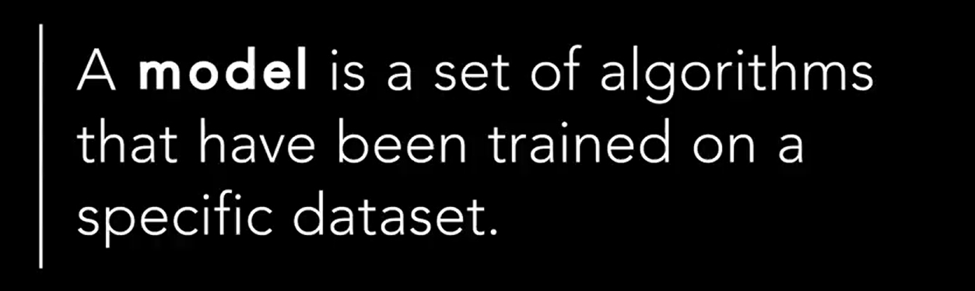

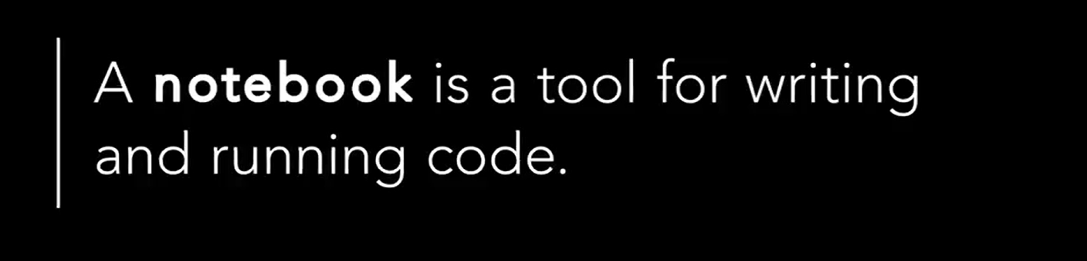

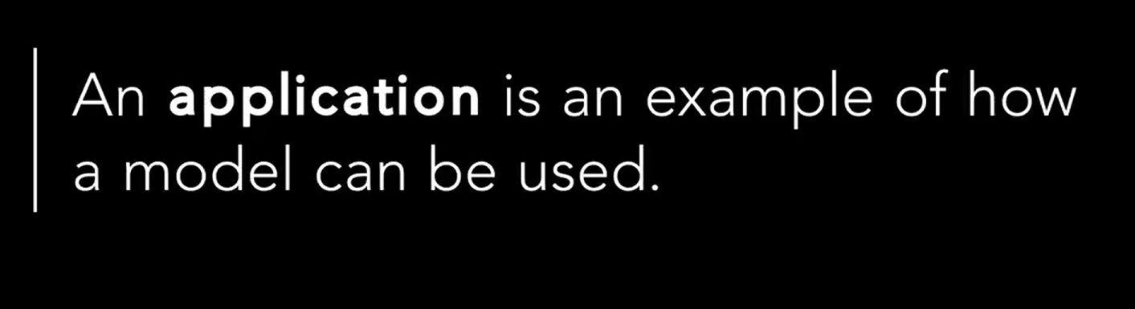

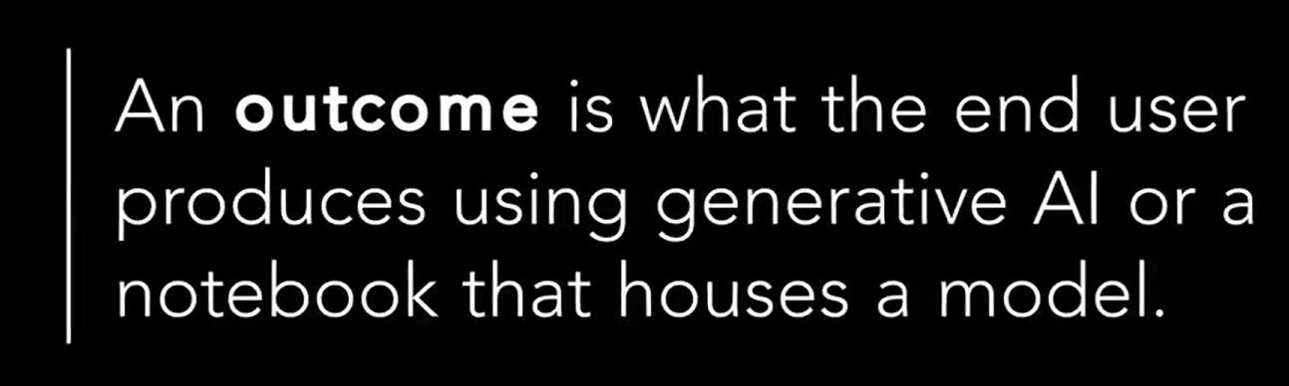

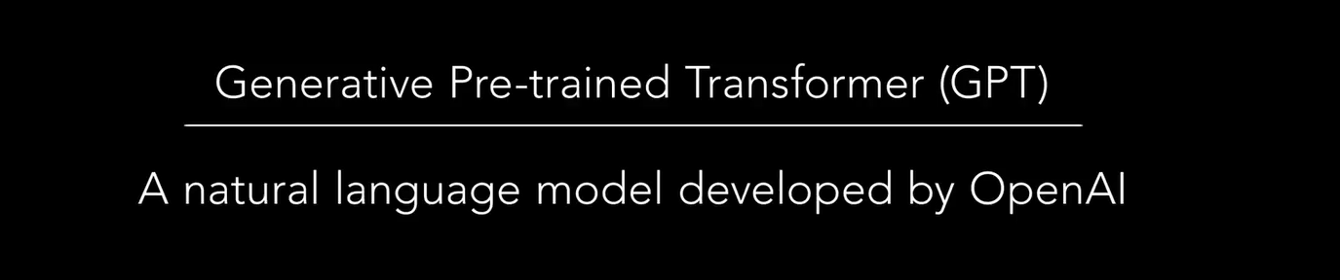

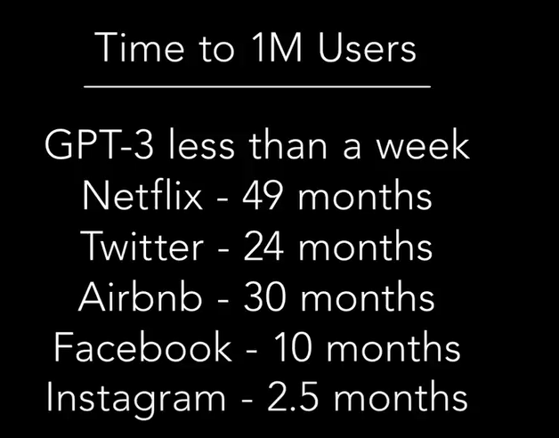

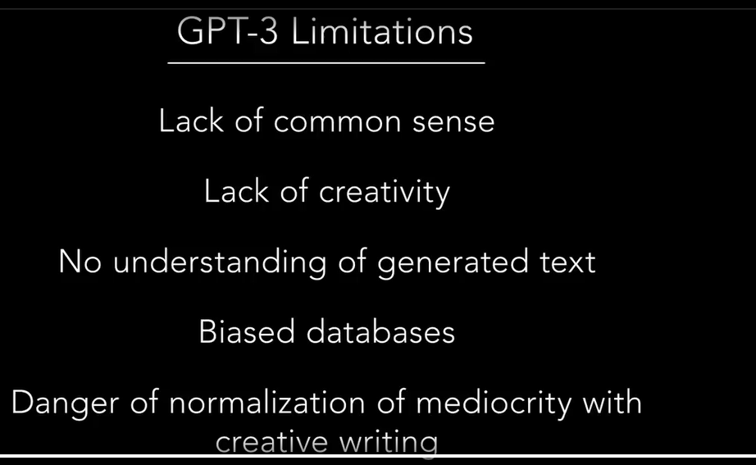

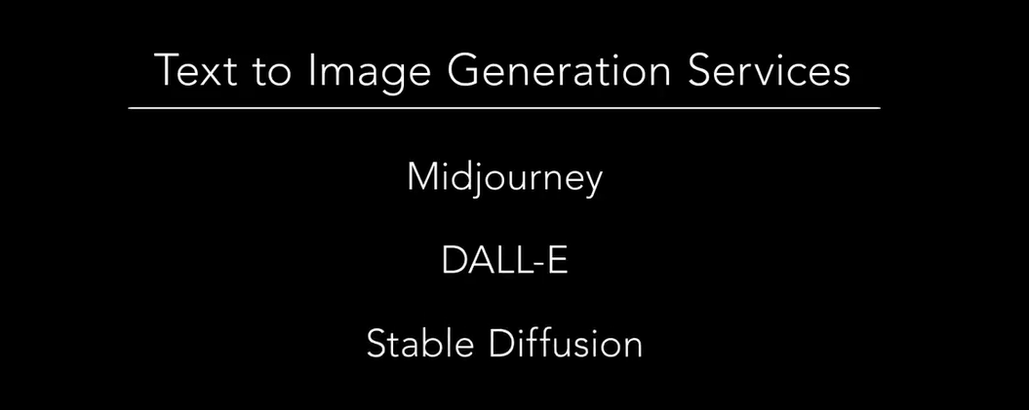

For Mack os , because

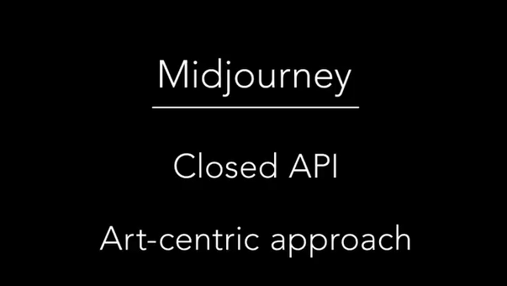

For windows we have

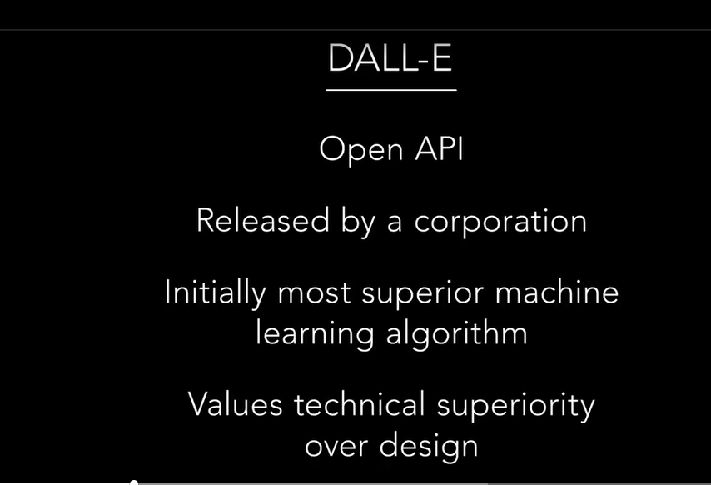

For linux we have

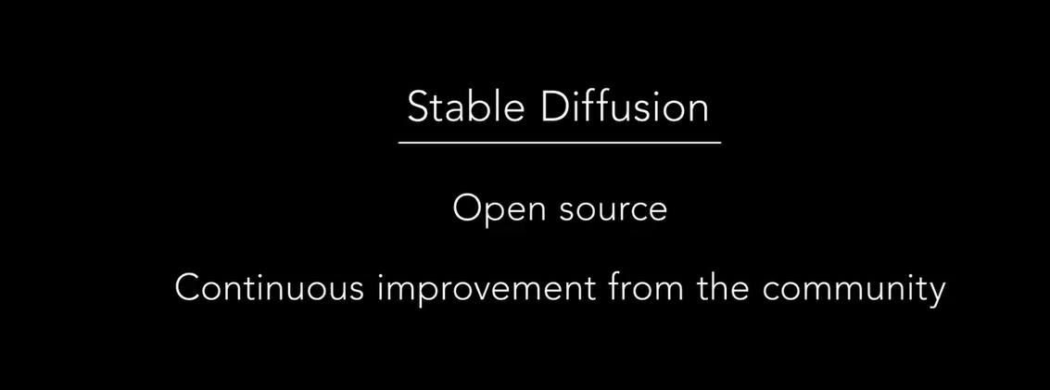

Lets look at industrial applications   
first Hollywood generative ai solution

This approach is time consuming with a lot of repetitive tasks



Another sample generated with dalle

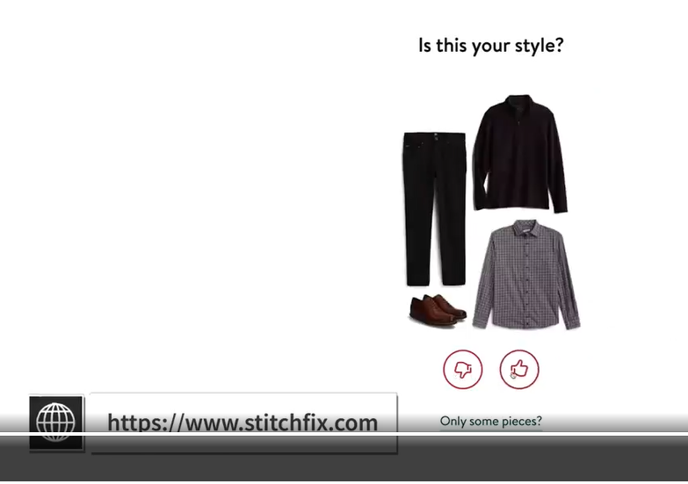

Marketer chose generative ai for the look and feel and for the savings

Another one is

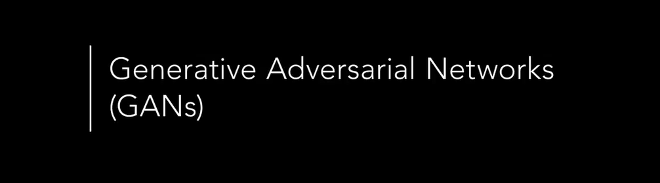

2 parties work in competion until the work is perfect

For example we can create a fake pating so close to the real one

That the creator of the new ai creation will work in conjunction with the descriminator which is the party to look for imperfectios

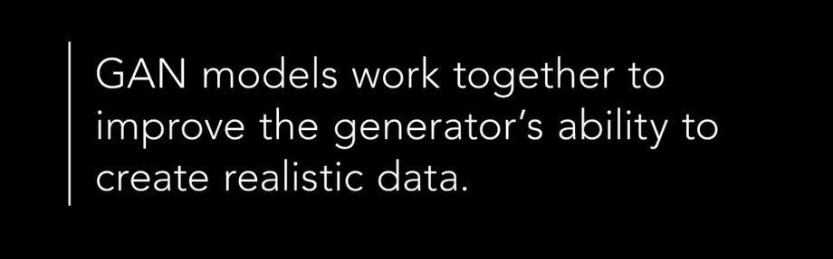

As a result we end creating better products and assets

Sample , audi car company used this tool to design some weel desigh . note to remmber that ai did not design the final design it was a tool desinner used to design a better looking weel

Also som company us this with setetic fradulaent models to detect frd in rea application

VAE can be trained on dataset of product , and it can be use then to detect bellow animalities , on product defect , city scans , financial fraud and others

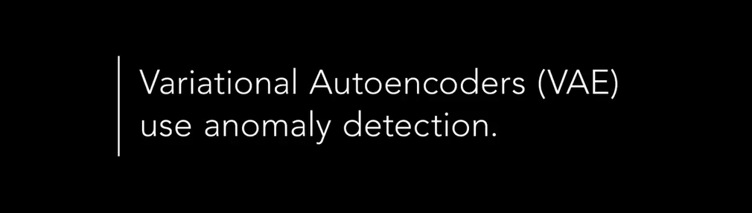

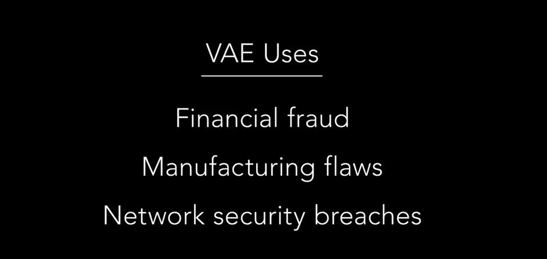

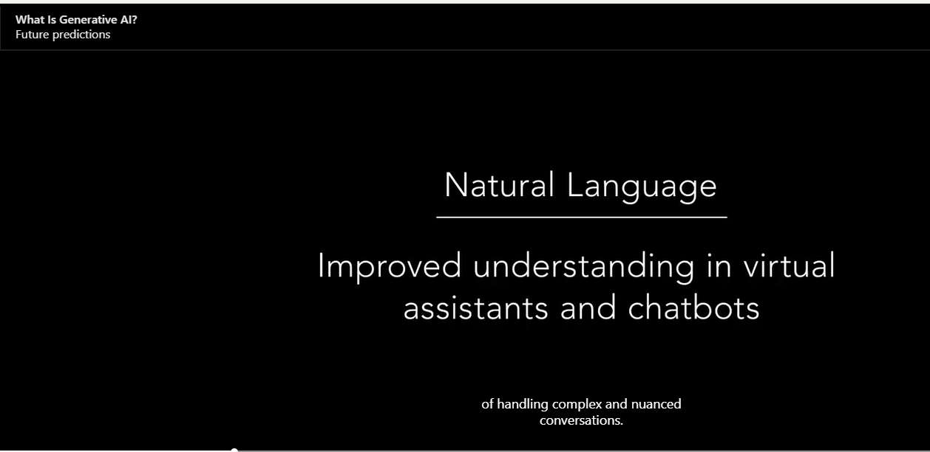

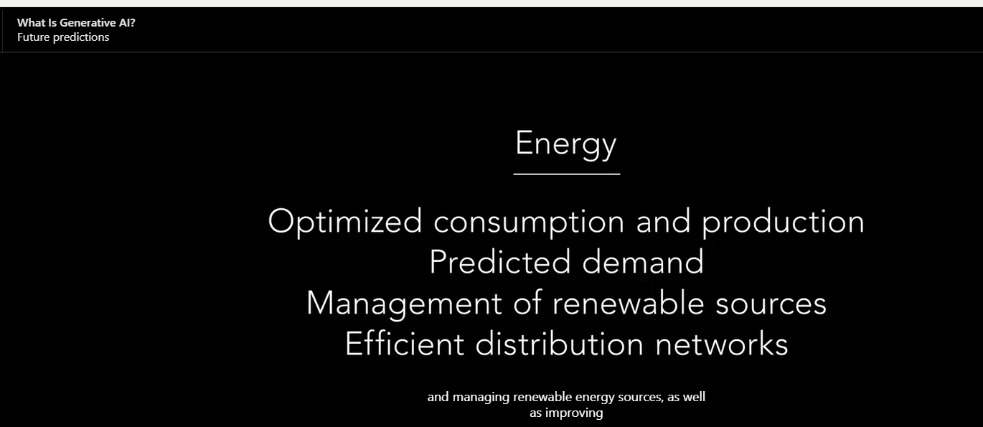

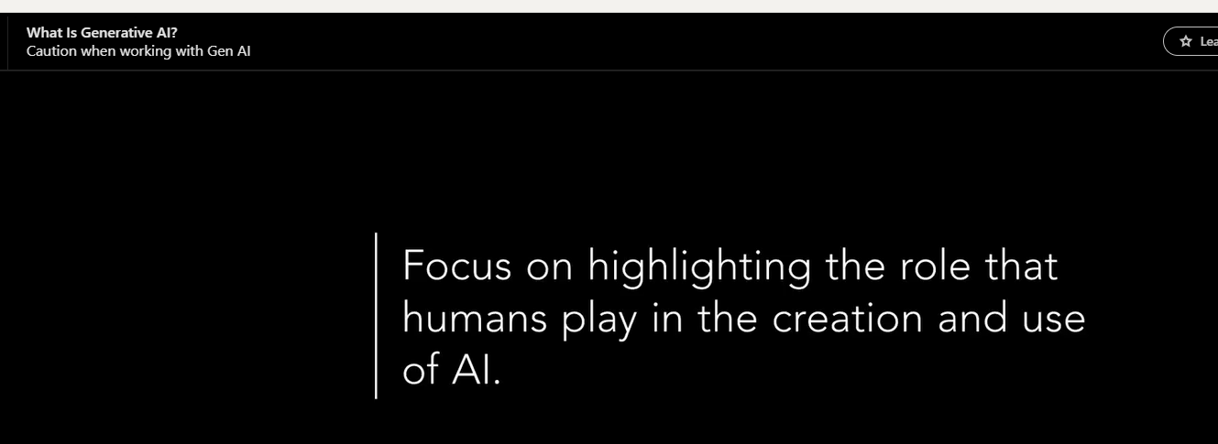

LLMs

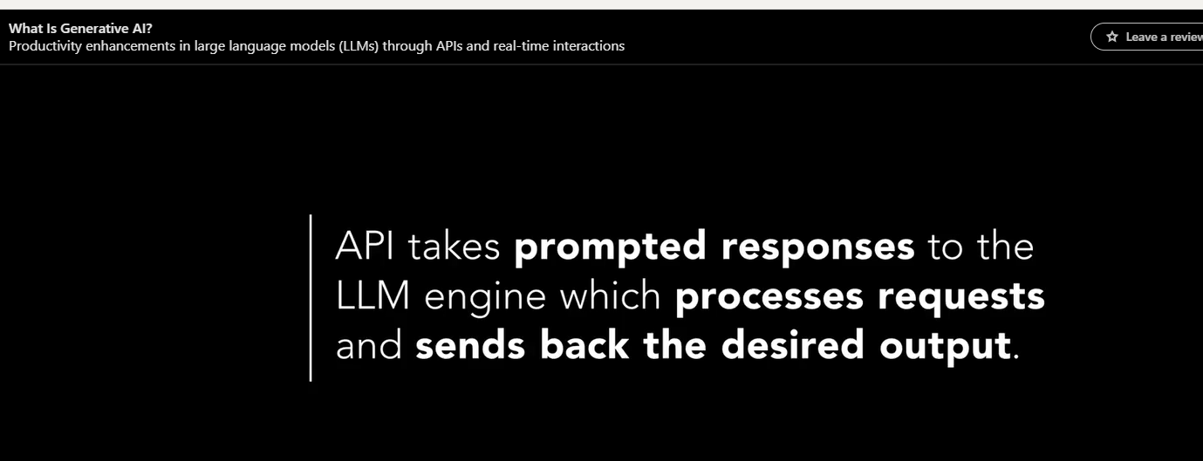

 for real conversation



Even though many has integrated ai into their work flow , still not ready for mass adoption

